Preparation and Distillation of Cyclohexene

**Reference:** Handout; Chemistry Lessons: Elimination/dehydration reactions, le Chatelier’s principle, distillations; Green Lessons: use of safer/milder reagents

**Purpose:** To synthesize cyclohexene from cyclohexanol from an acid-catalyzed dehydration reaction

**Table of Reagents:**

|  |  |  |  |  |
| --- | --- | --- | --- | --- |
| **Reagents** | **MW** | **BP (°C)** | **MP (°C)** | **Density** |
| Cyclohexanol | 100.158 g/mol | 161.8 °C | 25.93 °C | 0.9624 g/cm3 |
| Phosphoric Acid | 97.994 g/mol | 158 °C | 42.35 °C | 1.834 g/cm3 |
| Cyclohexene | 82.143 g/mol | 82.98 °C | 703.5 °C | - |

**Balanced Chemical Equation:**

* **Reaction**

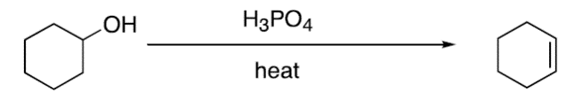

* **Mechanism**

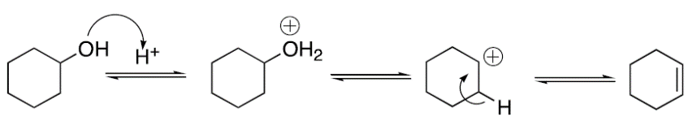

**Safety:**

* Cyclohexene 🡪 flammable and bad odor (place in ice bath below the collection flask)
* Phosphoric Acid 🡪 Corrosive (DO NOT TOUCH!)

|  |  |
| --- | --- |
| **Experimental Procedures** | **Data & Observations** |
| **1.** Obtain a 50 mL round-bottom flask with boiling chips; add 0.074 moles of cyclohexanol and 1.75 mL of 86% H3PO4. Swirl to mix! | *Cyclohexanol Used:* 7.4232 g |
| **2.** Follow diagram below to set-up distillation  ***Make sure seal is good with the rubber septum or cyclohexene will escape!*** | *Observations:*   * Distillation Flask 🡪 boiling * Collection Flask 🡪 foggy |
| **3.** Heat reaction mixture at low for 5 min, then slowly increase temperature. Keep distilling until volume remaining in distillation flask is ~1 mL |  |
| **4.** Transfer distillate to separatory funnel and wash with 5 mL of water. Separate the layers and transfer organic layer to dry Erlenmeyer flask.  **Remove any water droplets, before adding drying agent (NaSO4)*** | *Observations:*   * Organic Layer 🡪 top * Water 🡪 bottom |
| **5.**  Add Sodium Sulfate to flask and swirl gently. Let sit for 5 min. (If clumps happens, add more NaSO4). Drying agent should be free-flowing and liquid should be clear if water has been removed. |  |
| **6.** Decant/pipette liquid from drying agent into dry round bottom flask. (Distillation for next step)   * Appropriate size depends on yield; should be half full at beginning of distillation |  |
| **7.** Simple distillation 🡪 add distillation adapter and condenser to the flask; Be sure thermometer is positioned properly. Distill the organic material 🡪 collect in the 80 °C – 90 °C range. Record boiling range observed. |  |
| **8.** Determine mass of cyclohexene in weighted vial. If possible, record IR of sample. Seal and label vial with cyclohexene for next class | *Mass of Cyclohexene:* 1.0630 g |

**Post-lab Questions:**

**1.** Start 🡪 0.074 moles of Cyclohexanol used

$0.074 mol cyclohexanol×\frac{1 mol cyclohexene}{1 mol cyclohexanol}=0.074 moles of cyclohexene$

* The theoretical yield in obtaining cyclohexene should be equal to the initial amount used of cyclohexanol, since it’s a 1:1 ratio in reactants to products (depicted in the chemical equation above).

**2.**

* Mass of Cyclohexene Product: 1.0630 g

$\% Yield= \frac{Moles of Cyclohexene obtained}{Theoretical yield of Cyclohexene}$

$1.0630 g of Cyclohexene × \frac{1 mol}{82.143 g}=0.0129 mol of Cyclohexene$

$\% Yield= \frac{0.0129 moles}{0.074 moles} ×100=17.43 \% yield of Cyclohexene$

**3.** **Spectroscopic Interpretation**

**a. Spectra of Cyclohexene**

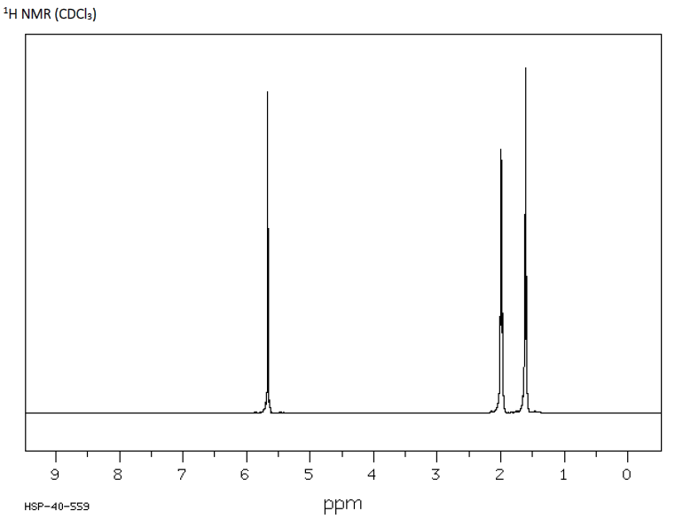

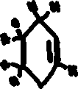

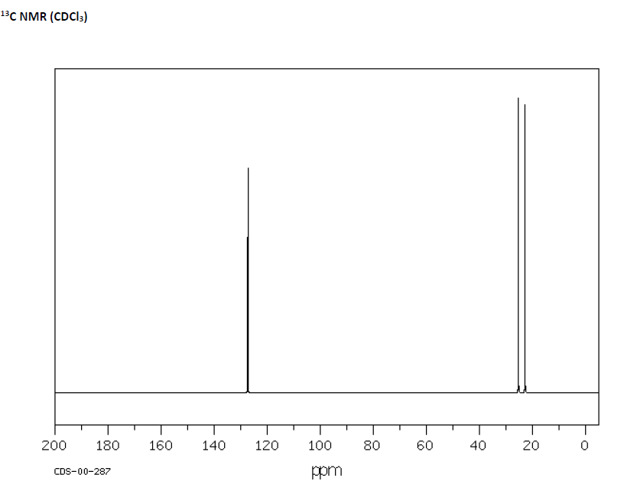

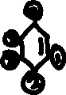

**b.**

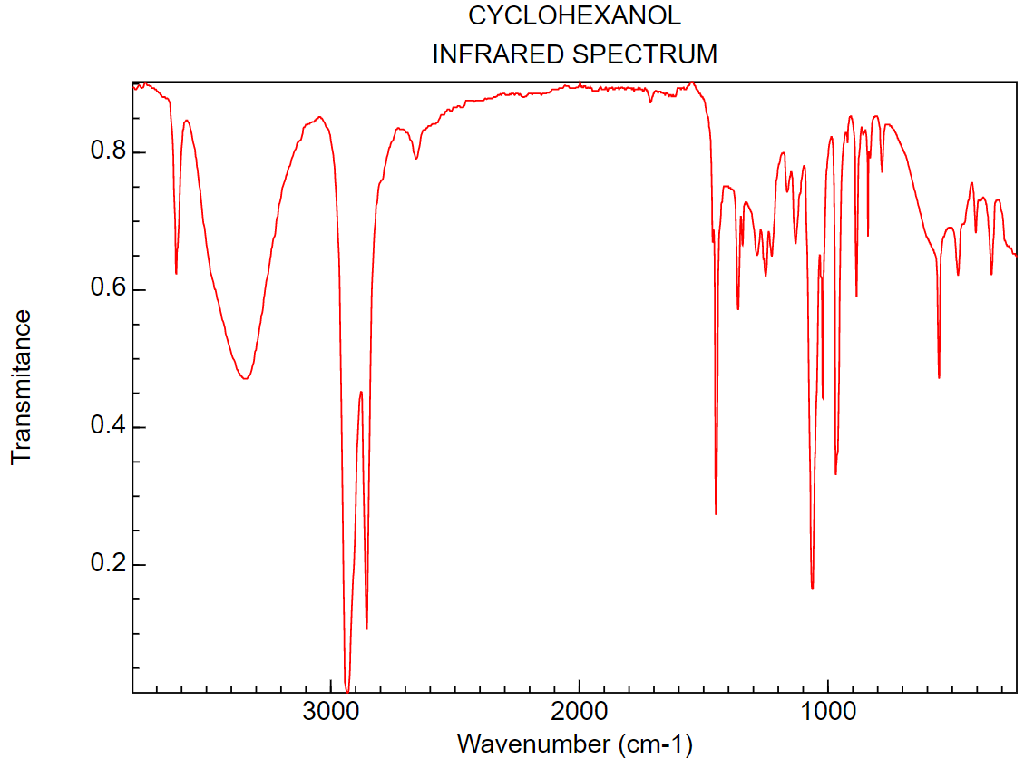

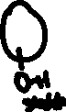

**c.** Yes, we will be able to determine if our reaction was a success, since cyclohexanol has a broad O-H stretch around the 3200 – 3500 cm-1, while cyclohexene does not have the O-H stretch. In addition, we will also be able to see the C=C, double bond stretch appearing around the 3010 – 3100 cm-1 on cyclohexene, which will be absent in cyclohexanol.

**4. Complete the sentence**

* Phospheric acid serves as a **catalyst** in this reaction.

**5.** In order to drive the reaction towards the products area, we must keep decreasing the amount of cyclohexene to the process going (if not will reach equilibrium). In addition, as stated in Le Chatlier’s principle, if a disturbance is present, the system wants to shift against the disturbance in order to maintiain equilibrium. In our case, we could increase the amount of phospheric acid (catalyst) or increase the temperature to further push the reaction towards the products resulting in a better yield.



**6.**

